Software Requirements Specification

for

Automatic scholarship calculation system

for PG and PhD students

based on recorded biometric attendance  
and guide's approval

Version 1.0

|  |  |  |
| --- | --- | --- |
| **S R Girish** | **B200797CS** | **srgirish_b200797cs@nitc.ac.in** |
| **Kristam Ram Kiran Yadav** | **B200805CS** | **kristam_b200805cs@nitc.ac.in** |
| **R Akshay** | **B200751CS** | **akshay_b200751cs@nitc.ac.in** |
| **Vinit kumawat** | **B200819CS** | **vinit_b200819cs@nitc.ac.in** |
| **Pachipala vishnu** | **B200811CS** | **pachipala_b200811cs@nitc.ac.in** |
| **Masaram Aditya ram** | **B200807CS** | **masaram_b200807cs@nitc.ac.in** |

Prepared by

Contents

Contents ii

Revisions ii

1 Introduction 1

1.1 Document Purpose 1

1.2 Product Scope 1

1.3 Intended Audience and Document Overview 1

1.4 Definitions, Acronyms and Abbreviations 1

1.5 Document Conventions 1

1.6 References and Acknowledgments 2

2 Overall Description 2

2.1 Product Overview 2

2.2 Product Functionality 3

2.3 Design and Implementation Constraints 3

2.4 Assumptions and Dependencies 3

3 Specific Requirements 4

3.1 External Interface Requirements 4

3.2 Functional Requirements 4

3.3 Use Case Model 5

4 Other Non-functional Requirements 6

4.1 Performance Requirements 6

4.2 Safety and Security Requirements 6

4.3 Software Quality Attributes 6

5 Other Requirements 7

Appendix A – Data Dictionary 8

Appendix B - Group Log 9

# Introduction

## Document Purpose

The purpose of this Software Requirement Specification (SRS) document is to give an overview of the functional and non-functional requirements of the Automatic scholarship calculation System based on bio-metric Attendance and guides approval . Based on this Document Students can get to know their scholarship details.

## Product Scope

The aim of this project is to develop a scholarship calculation System that would enable PG and PhD students to view their attendance and scholarship details. This Product can help automate the calculation of scholarship depending on attendance entries of a month.

Features:

● Users can view their attendance record.

● Users can view their scholarship details.

● Users can view guide details.

● Allows the administrators to monitor the attendance records.

● Guide can view students under them and approve accordingly.

## Intended Audience and Document Overview

Intended Audience: Guides,Students and Developers

Overview:

The rest of the document contains an overall description of the product including its functionalities , Design , the Use Case Model , The functional and nonfunctional requirements for the product. The sequence for reading the document for better understanding would be to start with the Overall Description of the Product which would result in understanding the Product Features and its dependencies ( more important for Professors) and then go through the hardware and software requirements to get an all overview of the required things to make sure the application runs smooth ( more important for Developers and Professors) and then checking the Use Case Model and its analysis ( Important for Developers) and at-last going through the other non functional requirements

## Definitions, Acronyms and Abbreviations

|  |  |
| --- | --- |
| Acronyms | Abbreviations |
| ASCS | Automatic Scholarship Calculation System |
| IEEE | Institute of Electrical and Electronics Engineers |
| OS | Operating System |
| SQL | Structured Query Language |

## Document Conventions

This document follows the IEEE formatting requirements. Arial font size 11 has been used throughout the document for text. Use of italics for comments. Use of bold for headings. Document text is single spaced and 1” margins are maintained in this document.

## References and Acknowledgments

* + - IEEE Std 830-1998 IEEE Recommended Practice for Software Requirements Specifications. IEEE Computer Society, 1998.
    - Lucidchart to create the use case diagram

We gratefully acknowledge the support from the Database Management system course teachers for the lectures and for the opportunity to collaborate with fellow peers on this project.

# Overall Description

## Product Overview

This application will serve as a platform where PG and PhD students know their attendance record and view their scholarship. The system administrators manage and update the system. They maintain the authenticity of the queries and have the authority to suspend a user. They also authenticate guide.

**DATA FLOW DIAGRAM**

**Level-0:**

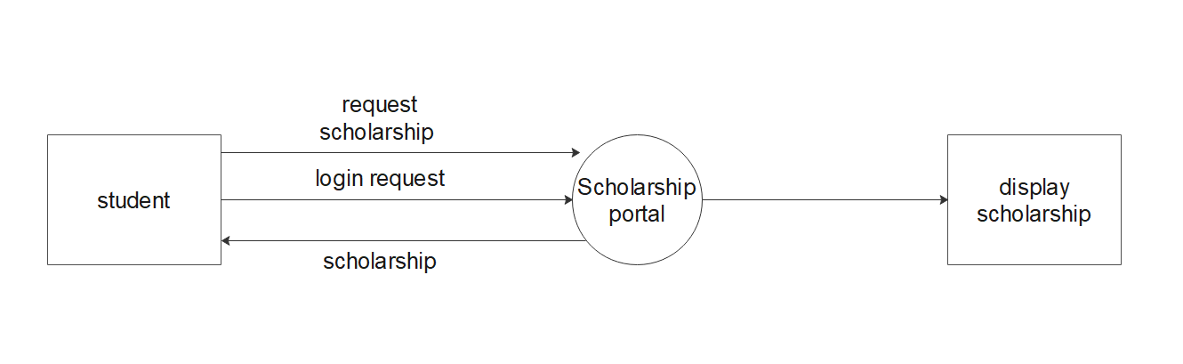

**Level-1:**

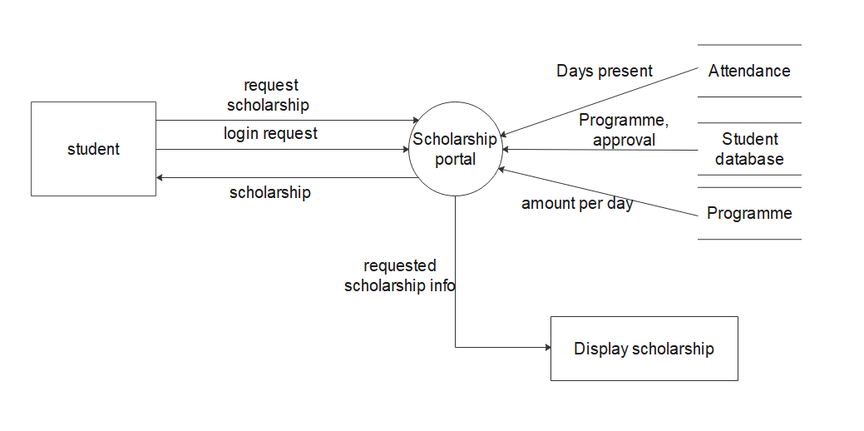

Level-2:

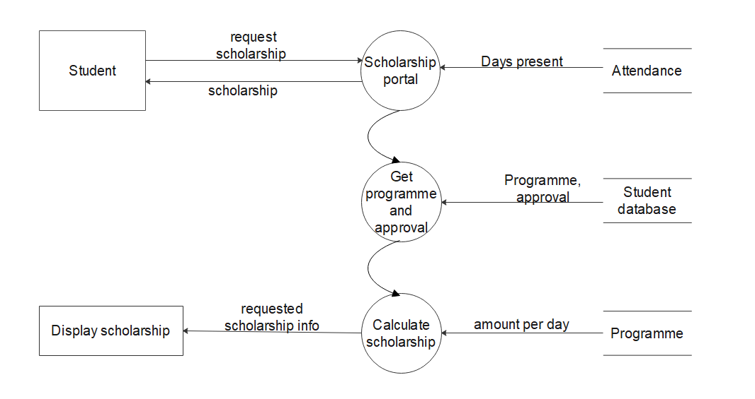

## 

## Product Functionality

College Social Media System has the following main functions:

* A student can view his attendance record.
* A student can get scholarship amount he can avail.
* A Guide can approve students that are assigned to him/her.
* A Guide can view his students attendance record.
* The Admin can add/remove students and guides.

## Design and Implementation Constraints

* **Development Environment**: The development environment used for the application is Windows OS, Visual Studio code editor.
* **Database**: The application relies on the database which contains data regarding attendance and personal details of all the students.
* **Security**: Since the application makes use of vital information about the institute and information that could affect the scholarship of students so only admin need to be able to modify any information.Students can only view the data and cannot do any changes to the database. Guide can only approve students .
* **Design conventions and standards**: This application development process must follow the principles specified by the Software Development Lifecycle (SDLC).

## Assumptions and Dependencies

* Since we will develop our application with Agile methods, user interfaces and functionalities may change in the future according to the need of the hour.
* Here we assume that a standard and functional biometric attendance system has been

set in place and this automatically updates the database.

* We assume that guide is fair to his students.

# **Specific Requirements**

**3.1 External Interface Requirements**

**3.1.1 User Interfaces:**

Users will interact using a web-app with the system that provides a simple and intuitive user interface. Based on the User role Functionalities will be extended.

**3.1.2 Hardware Interfaces:**

Processor :

i3 or greater

Ram : 512MB

Memory : Depends upon the Database size

**3.1.3 Software Interfaces** :

* The Front-end connects with Back-end through functional API’s.

Tech Stack:

FrontEnd: ReactJS,Bootstrap,Tailwind

Backend: Flask, MySQL